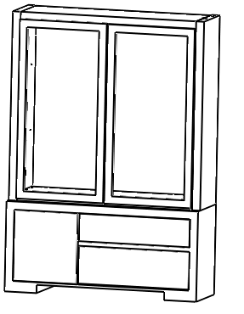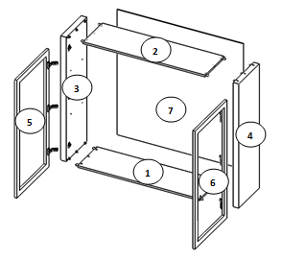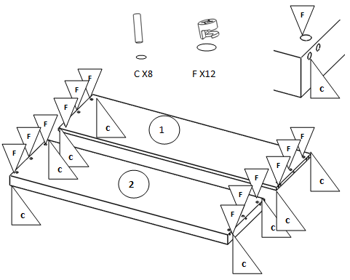

Ferragens e Ferramentas

**R x 30**

**C x 8**

**F x 8**

**P x 8**

**A x 6**

**B x 24**

**Vitrine Insignia**



**S x 8**

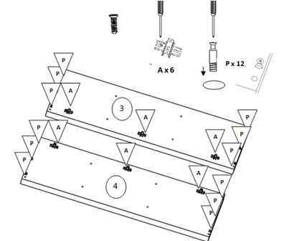

**B x 12**



**R x 30**

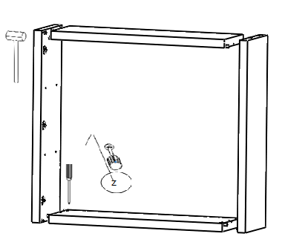

R

R

R

R

R

R

R

R

R

R

R

R

R

R

R

R

R

R

R

R

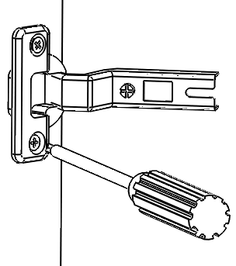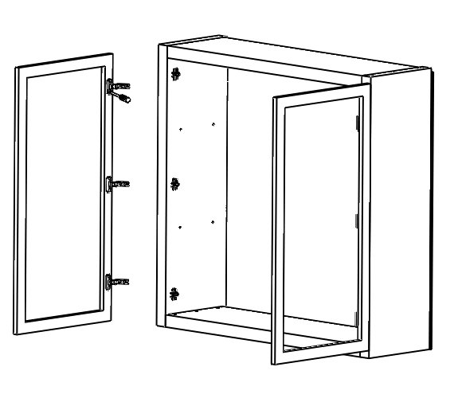

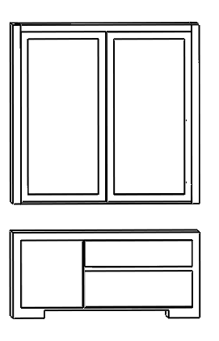

S

S

S

S

**S x 8**

**B x 12**